**MULUALEM KAHSSAY**

**21329429**

**Practical session 2**

*For the practical part of this lab please save the Python programs that you create and take screenshots of the execution (evaluation) of your programs.*

**Tasks:**

1) Write an algorithm that describes how to make scrambled eggs, try to use control words, like IF, WHEN, UNTIL, WHILE, WAIT, AND, OR.

1- Get a pan and a bowl

2- Beat eggs, milk, salt, and pepper in bowl until blended

3- Heat a small frying pan for a minute, then add butter and let it melt

4- Melt the butter slowly until it is frothy

5- While the butter is melting, pop a slice of whole wheat bread in the

toaster

6- Pour the egg mixture and let it sit in bowl until blended

7- Stir with a wooden spoon

8- Repeat until the eggs are softly set

9- Remove from the heater

10- Butter a toast and lay it on a plate, spoon scrambled egg on it

2) Is Idle (the Python language shell) an Interpreter or a Compiler or both? Explain your answer.

IDLE (integrated development learning environment) is a shell that allows to type in command in python and have it executed and see the outcome. Shell is an interpreter. A “shell” is a user interface for something. A python shell is way for a user to interact with python interpreter

A shell is usually an “interactive shell” usually termed as RELP stands for “Read – Execute – Print – Loop”. Compiler is used only for translation. It does not execute.

3) Write a command in the Idle shell that says “Hello world”

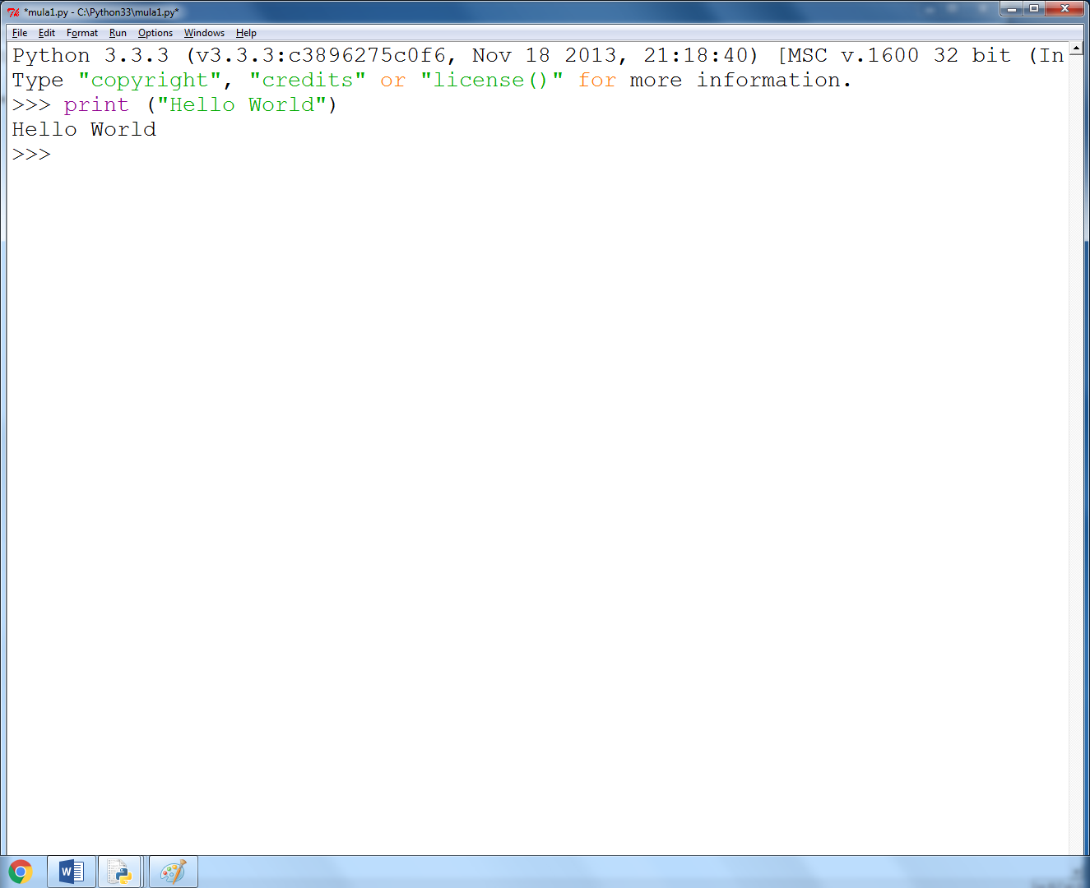

4) Write a program that produces the following output:

Hello World

I am in my ISD class right now

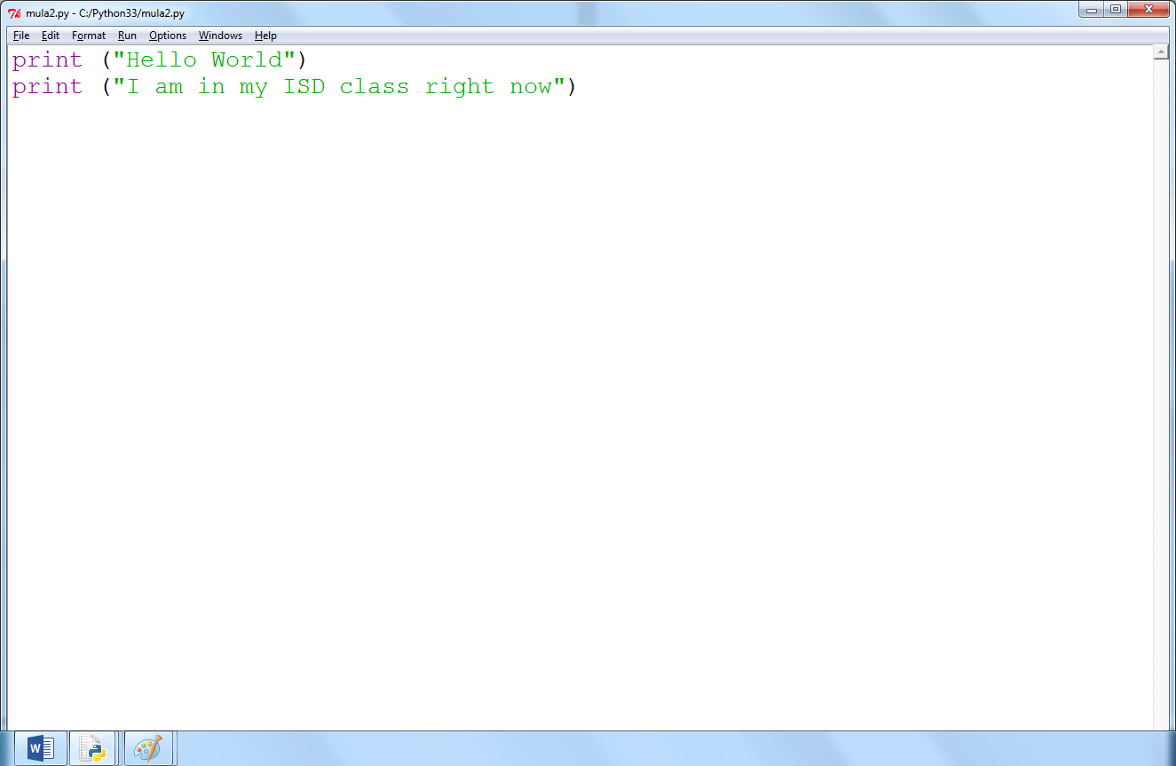

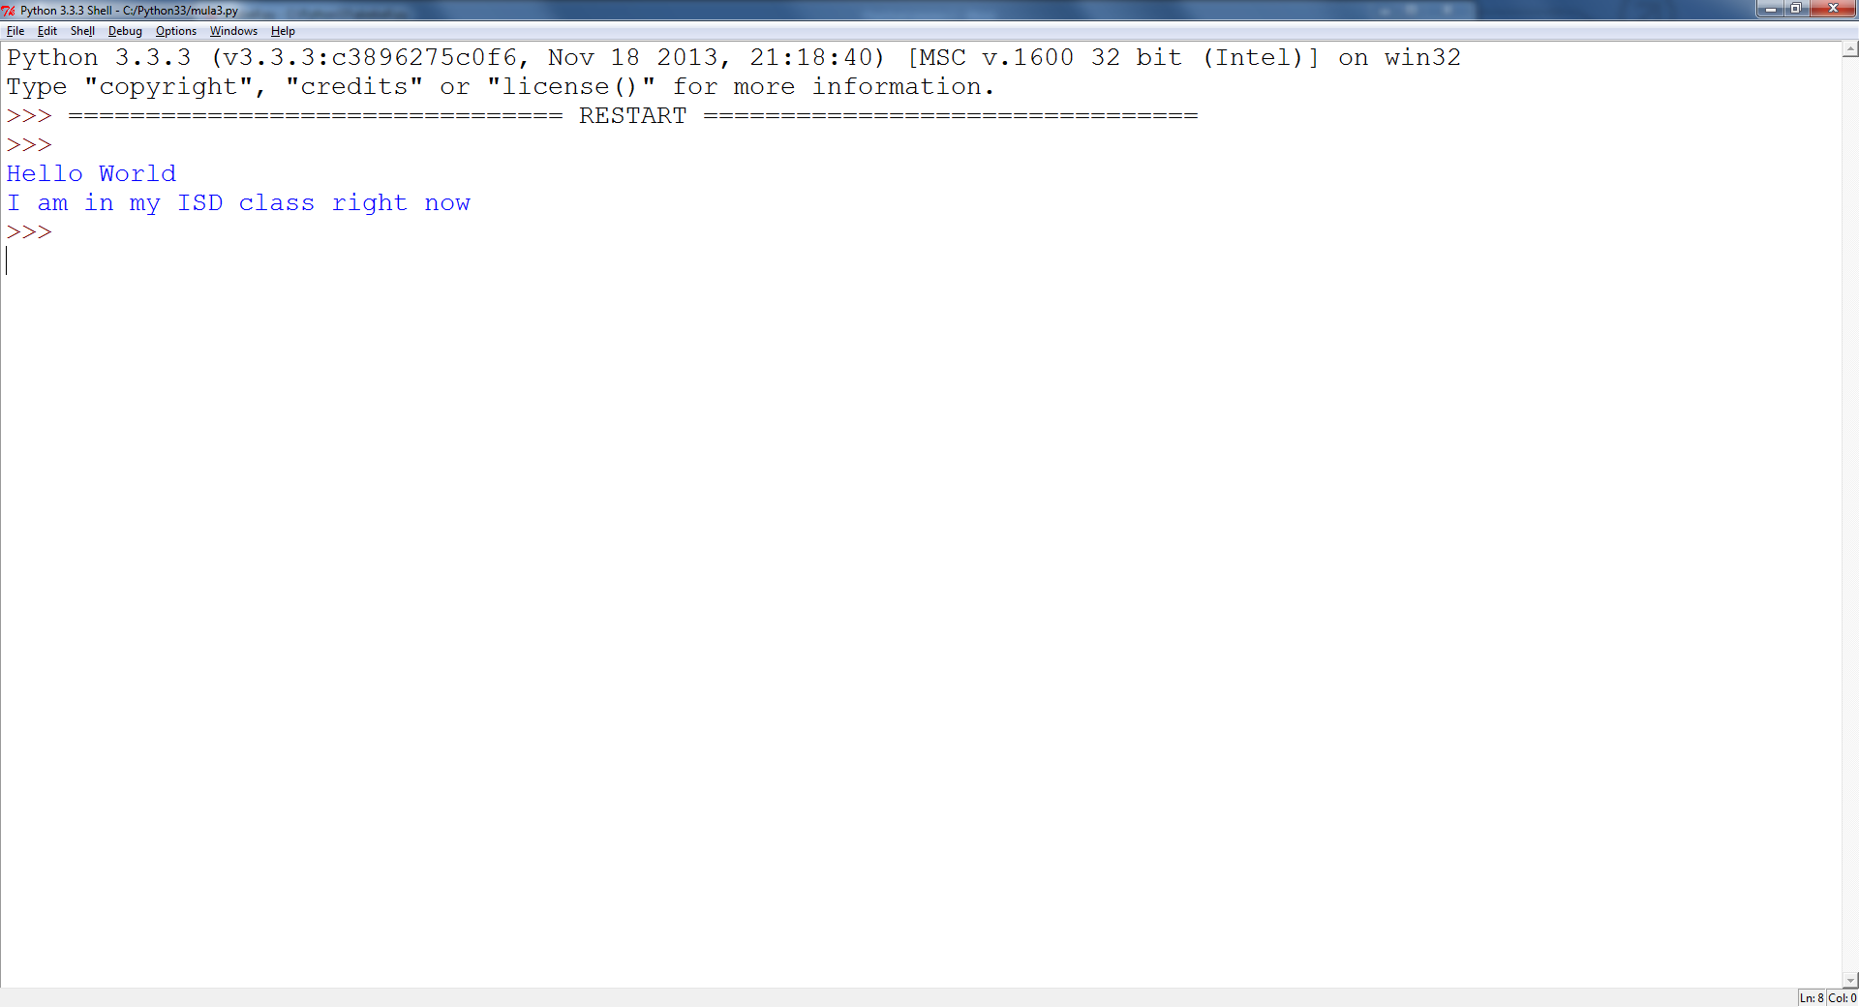

**Reminder on “Input”:**

A simple way to store variables (values) in your program is to use variables. Variables are placeholders that can store values, like strings (words), numbers (int) etc.

To create a variable, just give it a name and an initial value, for example for a number:

number = 7

or for a String (words):

myword = “This is my word”

5) Write a program that asks the user for his/her name and produces an output like:

Hi there, what is your name?

>User input to be read<

Hello

“User name”

How are you?

